
Semester Two Examination, 2021

Question/Answer Booklet

MATHEMATICS
METHODS
ATAR Year 12
Section One:
Calculator-free

Student Name: ______________________________________________________

Please circle your teacher’s name
Teacher: Miss Hosking Miss Rowden

Time allowed for this paper
Reading time before commencing work: 5 minutes
Working time for paper: 50 minutes

Materials required/recommended for this paper
To be provided by the supervisor
Number of additional
answer booklets used
(if applicable):
This Question/Answer Booklet
Formula Sheet

To be provided by the candidate
Standard items: pens (blue/black preferred), pencils (including coloured), sharpener, correction fluid/tape, eraser, ruler, highlighters

Special items: nil

Important note to candidates
No other items may be taken into the examination room. It is your responsibility to ensure that you do not have any unauthorised material. If you have any unauthorised material with you, hand it to the supervisor before reading any further.
Structure of this paper
Section | Number of questions available | Number of questions to be answered | Suggested working time (minutes) | Marks available | Percentage of examination
Section One:  Calculator free | 8 | 8 | 50 | 51 | 35
Section Two:  Calculator-assumed | 13 | 13 | 100 | 97 | 65
 |  |  |  | Total | 100

Instructions to candidates
- The rules for the conduct of the ATAR course examinations are detailed in the Year 12 Information Handbook 2021. Sitting this examination implies that you agree to abide by these rules.

- Write your answers in this Question/Answer booklet.

- You must be careful to confine your answers to the specific questions asked and to follow any instructions that are specific to a particular question.

- Supplementary pages for the use planning/continuing your answer to a question have been provided at the end of the Question/Answer booklet. If you use these pages to continue an answer, indicate at the original answer where the answer is continued, i.e. give the page number.

- Show all your working clearly. Your working should be in sufficient detail to allow your answers to be checked readily and for marks to be awarded for reasoning. Incorrect answers given without supporting reasoning cannot be allocated any marks. For any question or part question worth more than two marks, valid working or justification is required to receive full marks. If you repeat any question, ensure that you cancel the answer you do not wish to have marked.

- It is recommended that you do not use pencil, except in diagrams.

- The Formula sheet is not to be handed in with your Question/Answer booklet.

Section One: Calculator-free 35% (51 Marks)

This section has eight (8) questions. Answer all questions. Write your answers in the spaces
provided.

Supplementary pages for the use of planning/continuing your answer to a question have been provided at the end of this Question/Answer booklet. If you use these pages to continue an answer, indicate at the original answer where the answer is continued, i.e. give the page number.

Working time: 50 minutes.

Question 1 (5 marks)
(a) Determine $\int_{ }^{ }{\underset{ }{\overset{ }{\begin{matrix}4x+1 \\ \overline{{2x}^{2}+x-5}\end{matrix}}}}dx, x>1$. (2 marks)

(b) The line $y=12-2x$ intersects the curve $y=\begin{matrix}10 \\ \overline{ x }\end{matrix}$ at $(1, 10)$ and $(5, 2)$. Determine the area trapped between line and the curve. (3 marks)

Question 2 (5 marks)
A summary of the lengths of a large sample of nails from a production line are shown below.

Length, $L$ mm | Relative frequency
$$147<L≤148$$ | $$0.17$$
$$148<L≤149$$ | $$0.13$$
$$149<L≤150$$ | $$0.21$$
$$150<L≤151$$ | $$0.19$$
$$151<L≤152$$ | $$0.16$$
$$152<L≤153$$ | $$0.14$$

(a) What proportion of nails are longer than $149$ mm? (1 mark)

(b) Determine the probability that a randomly selected nail from the production line is longer than $150$ mm given that it is no longer than $152$ mm. (2 marks)

(c) State, with reasons, whether the data suggests that the nail lengths are normally distributed. (2 marks)

Question 3 (7 marks)
The curve $y=8x-\begin{matrix}4 \\ \overline{x^{2}}\end{matrix}$ has one stationary point.
(a) Obtain expressions for $\begin{matrix}dy \\ \overline{dx}\end{matrix}$ and $\begin{matrix}d^{2}y \\ \overline{dx^{2}}\end{matrix}$ . (2 marks)

(b) Determine the coordinates of the stationary point and determine its nature. (4 marks)

(c) Explain why the curve has no point of inflection. (1 mark)

Question 4 (7 marks)
(a) Let $F\left(x\right)=\int_{0}^{x}{\underset{ }{\overset{ }{\sin{2θ}}}}dθ$.
Express $F(x)$ as a function of $x$ and hence evaluate $F\left(\begin{matrix}π \\ \overline{6}\end{matrix}\right)$.
(3 marks)

Question 4 continued

(b) Let $g\left(x\right)=\begin{matrix}e^{2x-1} \\ \overline{2x+1}\end{matrix}$ .

(i) Show that $g'(x)=\begin{matrix}4x e^{2x-1} \\ \overline{{\left(2x+1\right)}^{2}}\end{matrix}$ . (2 marks)

(ii) Hence, or otherwise, evaluate $\int_{0}^{1}{\underset{ }{\overset{ }{\begin{matrix}x e^{2x-1} \\ \overline{{\left(2x+1\right)}^{2}}\end{matrix}}}}dx$. (2 marks)

Question 5 (7 marks)
(a) By first using log laws, or otherwise, determine $\begin{matrix}d \\ \overline{dx}\end{matrix}\left(\ln\left(e^{3x}\sqrt{x^{2}+3}\right)\right)$ in simplest form.
(3 marks)

(b) The function $f\left(x\right)=x^{2}\ln{(2x)}$ for $x>0$ has one stationary point, a global minimum.
Determine the minimum value of the function. (4 marks)

Question 6 (6 marks)
The graph of $y=f(x)$ consists of line segments, as shown below.

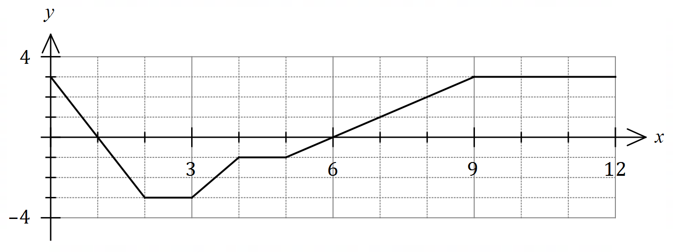
Evaluate each of the following:

(a) $\int_{7}^{10}{\underset{ }{\overset{ }{f(x)}}}dx$. (1 mark)

(b) $\int_{3}^{8}{\underset{ }{\overset{ }{f(x)}}}dx$. (2 marks)

(c) $\int_{0}^{9}{\underset{ }{\overset{ }{\left(f(x)+2\right)}}}dx$. (3 marks)

Question 7 (8 marks)
The random variable $X$ is defined by $P\left(X=x\right)=\left\{\begin{matrix}k\log_{3}{(x+2)} & x=1, 25, 79 \\ & \\ 0 & \text{elsewhere}\end{matrix}\right.$

(a) Determine the value of the constant $k$. (2 marks)

(b) Calculate the expected value of $X$. (2 marks)

The Bernoulli random variable $Y$ is solely dependent on $X$, so that $Y=1$ when $X=1$, and $Y=0$ for all other values of $X$.

(c) Determine

(i) $P(Y=0)$. (1 mark)

(ii) $E(Y)$. (1 mark)

(iii) $\operatorname{Var}{(3Y+1)}$. (2 marks)

Question 8 (6 marks)
In triangle $ABC$, the length of the side opposite angle $A$ is given by $a=\sqrt{13-6\cos{A}}$ cm.

Use the increments formula to calculate the approximate change in length of $a$ as the size of angle $A$ decreases from $\begin{matrix}20π \\ \overline{ 30 }\end{matrix}$ to $\begin{matrix}19π \\ \overline{ 30 }\end{matrix}$.

Supplementary page

Question number: _____________________

Supplementary page

Question number: _____________________

Supplementary page

Question number: _____________________

